IE 441

PLANNING FOR ENGINEERS

INSTRUCTOR:TANER BİLGİÇ

Homework 3

SİNAN DEMİRHAN

2016402330

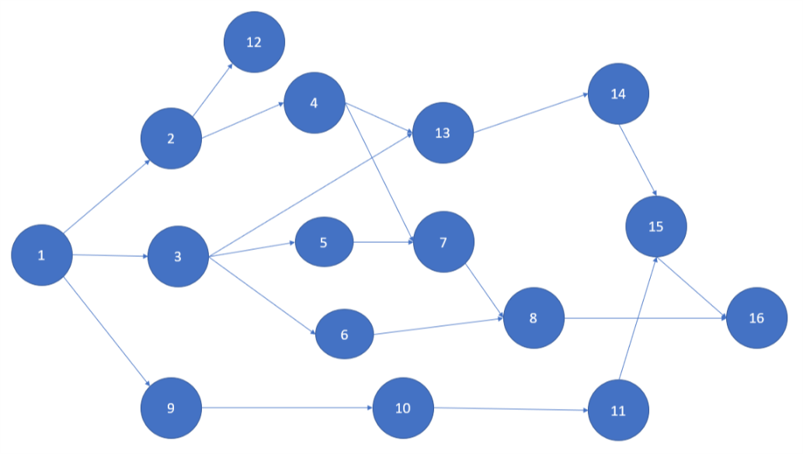

1-a,c) Using the Normal Durations,

|  |  |  |  |  |  |  |  |  |
| --- | --- | --- | --- | --- | --- | --- | --- | --- |
|  | ES | EF | LS | LF | TS | FS | SS | IF |
| T1 | 0 | 3 | 0 | 3 | 0 | 0 | 0 | 0 |
| T2 | 3 | 7 | 3 | 7 | 0 | 0 | 0 | 0 |
| T3 | 3 | 5 | 10 | 12 | 7 | 0 | 7 | 0 |
| T4 | 7 | 12 | 7 | 12 | 0 | 0 | 0 | 0 |
| T5 | 5 | 6 | 23 | 24 | 18 | 6 | 11 | 0 |
| T6 | 5 | 7 | 21 | 28 | 16 | 9 | 9 | 2 |
| T7 | 12 | 16 | 24 | 28 | 12 | 0 | 0 | 0 |
| T8 | 16 | 19 | 28 | 31 | 12 | 12 | 0 | 0 |
| T9 | 3 | 8 | 9 | 14 | 6 | 0 | 6 | 0 |
| T10 | 8 | 12 | 14 | 17 | 6 | 0 | 0 | 0 |
| T11 | 12 | 18 | 17 | 23 | 5 | 13 | 0 | 0 |
| T12 | 7 | 15 | 23 | 31 | 16 | 16 | 16 | 16 |
| T13 | 12 | 21 | 12 | 21 | 0 | 0 | 0 | 0 |
| T14 | 21 | 23 | 21 | 23 | 0 | 0 | 0 | 0 |
| T15 | 23 | 31 | 23 | 31 | 0 | 0 | 0 | 0 |
| T16 | 31 | 31 | 31 | 31 | 0 | 0 | 0 | 0 |

1-b) The critical path is T1-T2-T4-T13-T14-T15-T16

The Project will finish in 31 days.

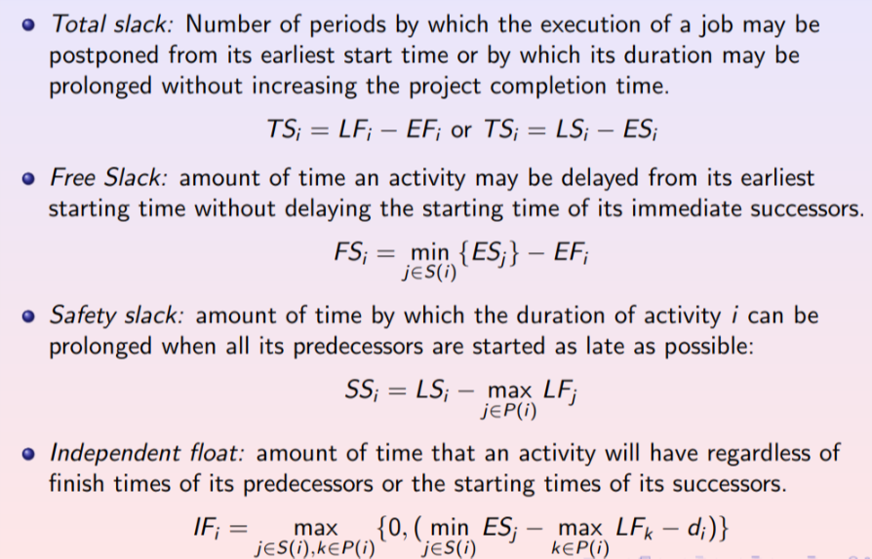

2-a,c) Using the Crashed Durations

|  |  |  |  |  |  |  |  |  |
| --- | --- | --- | --- | --- | --- | --- | --- | --- |
|  | ES | EF | LS | LF | TS | FS | SS | IF |
| T1 | 0 | 2 | 0 | 2 | 0 | 0 | 0 | 0 |
| T2 | 2 | 4 | 2 | 4 | 0 | 0 | 0 | 0 |
| T3 | 2 | 4 | 4 | 7 | 3 | 0 | 2 | 0 |
| T4 | 4 | 7 | 4 | 7 | 0 | 0 | 0 | 0 |
| T5 | 4 | 5 | 14 | 15 | 10 | 2 | 7 | 0 |
| T6 | 4 | 6 | 17 | 19 | 13 | 5 | 10 | 2 |
| T7 | 7 | 11 | 15 | 19 | 8 | 0 | 0 | 0 |
| T8 | 11 | 14 | 19 | 22 | 8 | 8 | 0 | 0 |
| T9 | 2 | 7 | 2 | 7 | 0 | 0 | 0 | 0 |
| T10 | 7 | 10 | 7 | 10 | 0 | 0 | 0 | 0 |
| T11 | 10 | 14 | 10 | 14 | 0 | 0 | 0 | 0 |
| T12 | 4 | 12 | 14 | 22 | 10 | 10 | 10 | 10 |
| T13 | 7 | 13 | 7 | 13 | 0 | 0 | 0 | 0 |
| T14 | 13 | 14 | 13 | 14 | 0 | 0 | 0 | 0 |
| T15 | 14 | 22 | 14 | 22 | 0 | 0 | 0 | 0 |
| T16 | 22 | 22 | 22 | 22 | 0 | 0 | 0 | 0 |

2-b)

The critical path is T1-T2-T4-T13-T14-T15-T16 and T1-T9-T10-T11-T15-T16.

The project will finish in 22 days.

3-)

The critical path is T1-T2-T4-T13-T14-T15-T16 and T1-T9-T10-T11-T15-T16.

Their criticality level are the same for this two path.

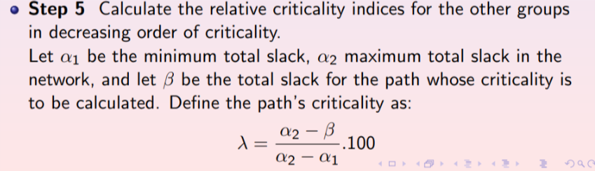

λ

α1=0

α2=13

|  |  |
| --- | --- |
| Path | Criticality Levels |
| T1-T2-T4-T13-T14-T15-T16 | 100 |
| T1-T9-T10-T11-T15-T16 | 100 |
| T1-T3-T13-T14-T15-T16 | 76 |
| T1-T2-T4-T7-T8-T16 | 38 |
| T1-T3-T7-T8-T16 | 38 |
| T1-T2-T12 | 38 |
| T1-T3-T5-T7-T8-T16 | 0 |
| T1-T3-T6-T8-T16 | 0 |
| T1-T9-T6-T8-T16 | 0 |

4-)

|  |  |  |  |
| --- | --- | --- | --- |
|  | CC-NC | ND-CD | Expedite cost per day |
| T1 | 100 | 1 | 100 |
| T2 | 300 | 2 | 150 |
| T3 | 0 | 0 | 0 |
| T4 | 460 | 2 | 230 |
| T5 | 0 | 0 | 0 |
| T6 | 0 | 0 | 0 |
| T7 | 0 | 0 | 0 |
| T8 | 0 | 0 | 0 |
| T9 | 0 | 0 | 0 |
| T10 | 0 | 0 | 0 |
| T11 | 270 | 2 | 135 |
| T12 | 0 | 0 | 0 |
| T13 | 420 | 3 | 160 |
| T14 | 200 | 1 | 200 |
| T15 | 340 | 2 | 170 |
| T16 | 0 | 0 | 0 |

7-)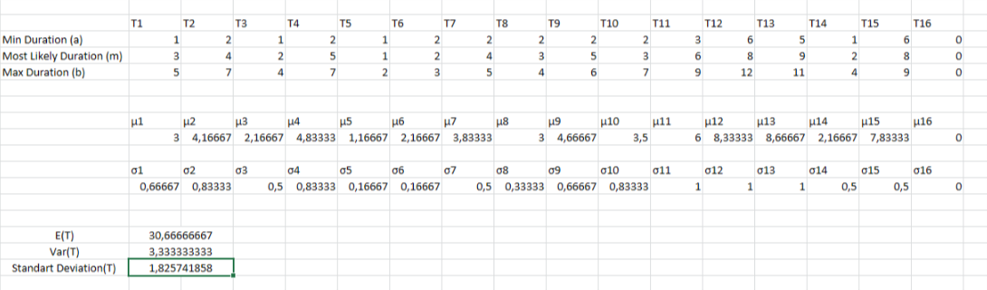

The critical path is T1-T2-T4-T13-T14-T15-T16.

The expected project completion time is 30,6 days and its standard deviation is 1,82.

8-)

P(X<25)=?

(25-30,6)/1,82=-3,08

=P(Z<-3.08)=pnorm(-3.08)= 0.001035003

9-)

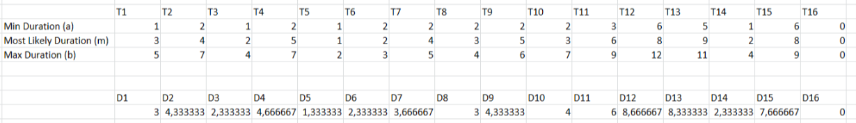Durations=(a+m+b)/3

|  |  |
| --- | --- |
|  | TS |
| T1 | 0 |
| T2 | 0 |
| T3 | 6,83 |
| T4 | 0 |
| T5 | 17,5 |
| T6 | 17,83 |
| T7 | 11,83 |
| T8 | 11,83 |
| T9 | 5,66 |
| T10 | 5,66 |
| T11 | 5,66 |
| T12 | 15,16 |
| T13 | 0 |
| T14 | 0 |
| T15 | 0 |
| T16 | 0 |

α1=0

α2=17,83

|  |  |
| --- | --- |
| Path | Criticality level |
| T1-T2-T4-T13-T14-T15-T16 | 100 |
| T1-T9-T10-T11-T15-T16 | 68 |
| T1-T2-T4-T7-T8-T16 | 33 |
| T1-T3-T13-T14-T15-T16 | 61 |
| T1-T2-T12 | 14 |
| T1-T3-T7-T8-T16 | 33 |
| T1-T3-T5-T7-T8-T16 | 1 |
| T1-T3-T6-T8-T16 | 0 |
| T1-T9-T6-T8-T16 | 0 |

10-)

The answer in the 8th question did not change when we see the criticality levels of other paths.however,because we don’t know the exact durations of the paths or nodes,according to the different durations between min and max values can effect the critical path